TITLE PAGE

Digital Literacy Project Report

Name: Sujal Jainani
Registration Number: 25BEC10022
Branch: B.Tech ECE
Year: 1st Year
Course Code: CSE0001
University: VIT Bhopal University
Date: 27/03/2026

INTRODUCTION

Introduction
Digital literacy is an essential skill in the today’s modern world where technology plays a major role in the education, communication, and daily life. This project was assigned to help students understand the importance of digital tools, online platforms, communication etiquette, and cyber safety.

As a Student Digital Ambassador, the objective of this project is to create the awareness among peers about responsible and effective use of digital resources. Throughout this project, I explored various platforms such as GitHub, LinkedIn, and Google Forms, and learned how to present information using tools like Canva.

The project also helped me understand professional communication through email writing and the importance of staying safe from cybercrime. Overall, this project enhanced my digital knowledge and practical skills.

Task 1: Digital Literacy Infographic
Below is the infographic created for digital literacy awareness:
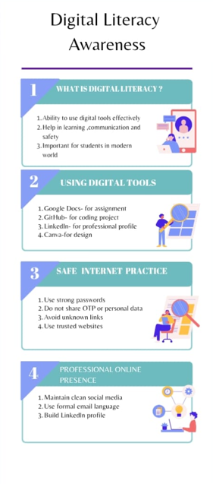
I have created a digital literacy awareness infographic using Canva, which is a user-friendly online design tool. The infographic covers important aspects of the digital literacy such as its meaning, useful digital tools for students, safe internet practices, and maintaining a professional online presence. I have included tools like Google Docs, GitHub, LinkedIn, and Canva to show how students can effectively use digital platforms for learning and communication.
While designing the infographic, I focused on making it visually attractive and easy to understand. I used simple language, icons, and proper sections to organize the content. One challenge I faced was selecting a suitable layout and ensuring that the content was not overcrowded. However, this helped me improve my creativity and design skills.
This task helped me understand how digital information can be presented effectively. It also increased my awareness of digital literacy and its importance in everyday life.
Task 2: Digital Portfolio
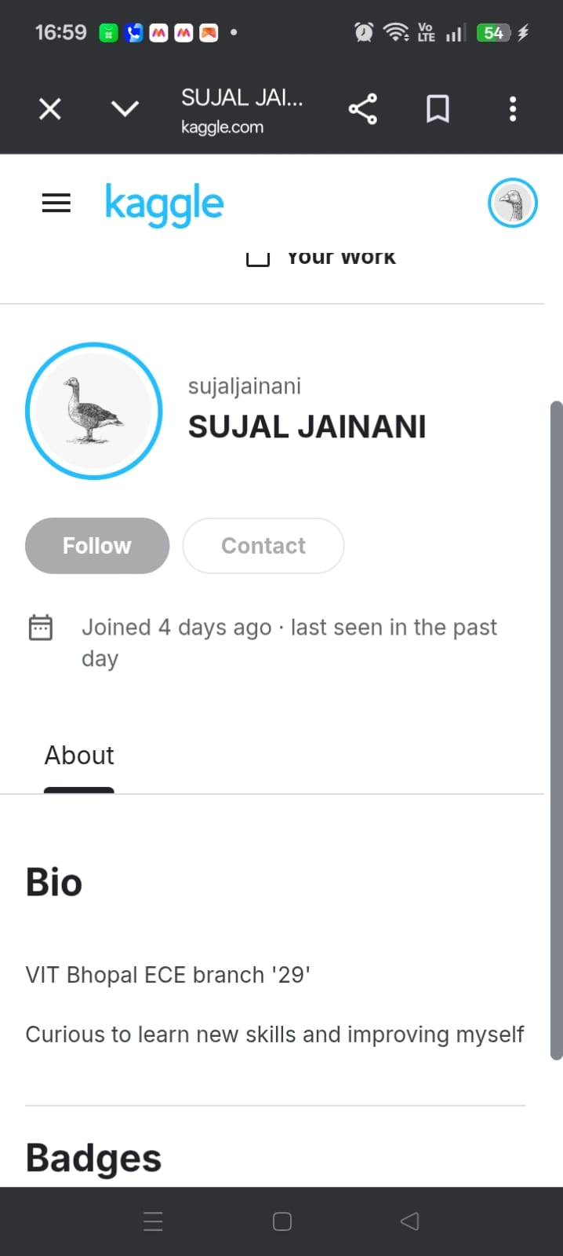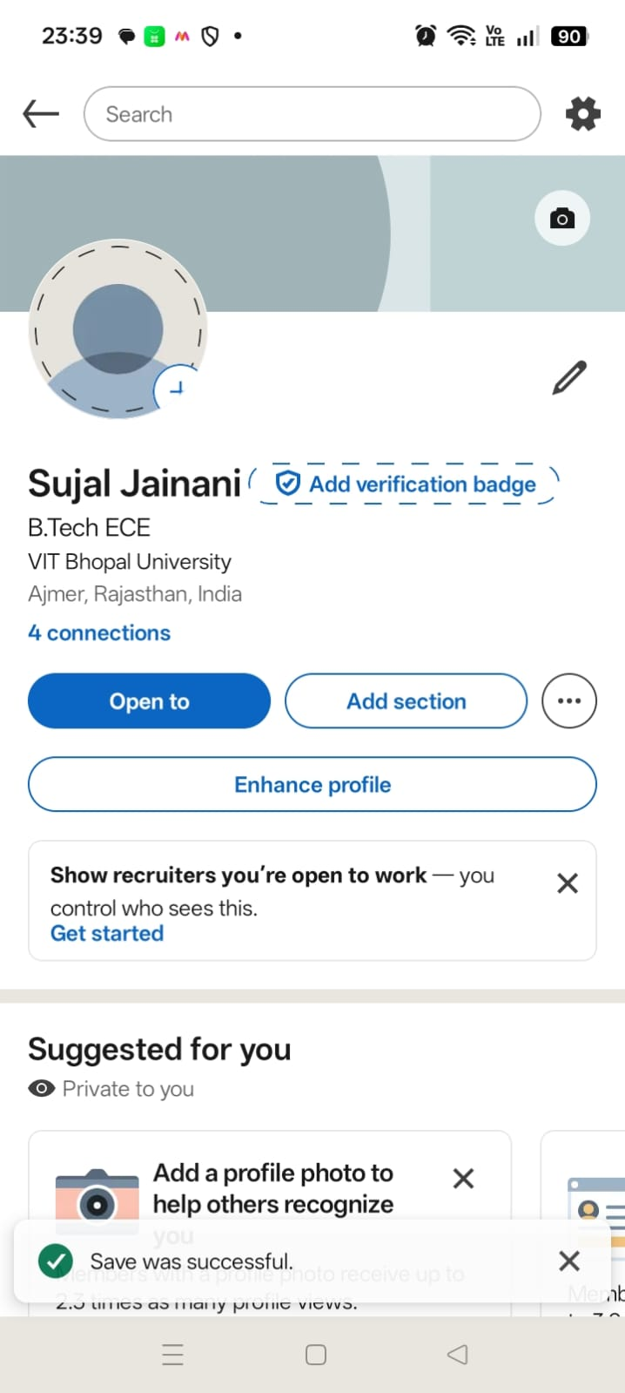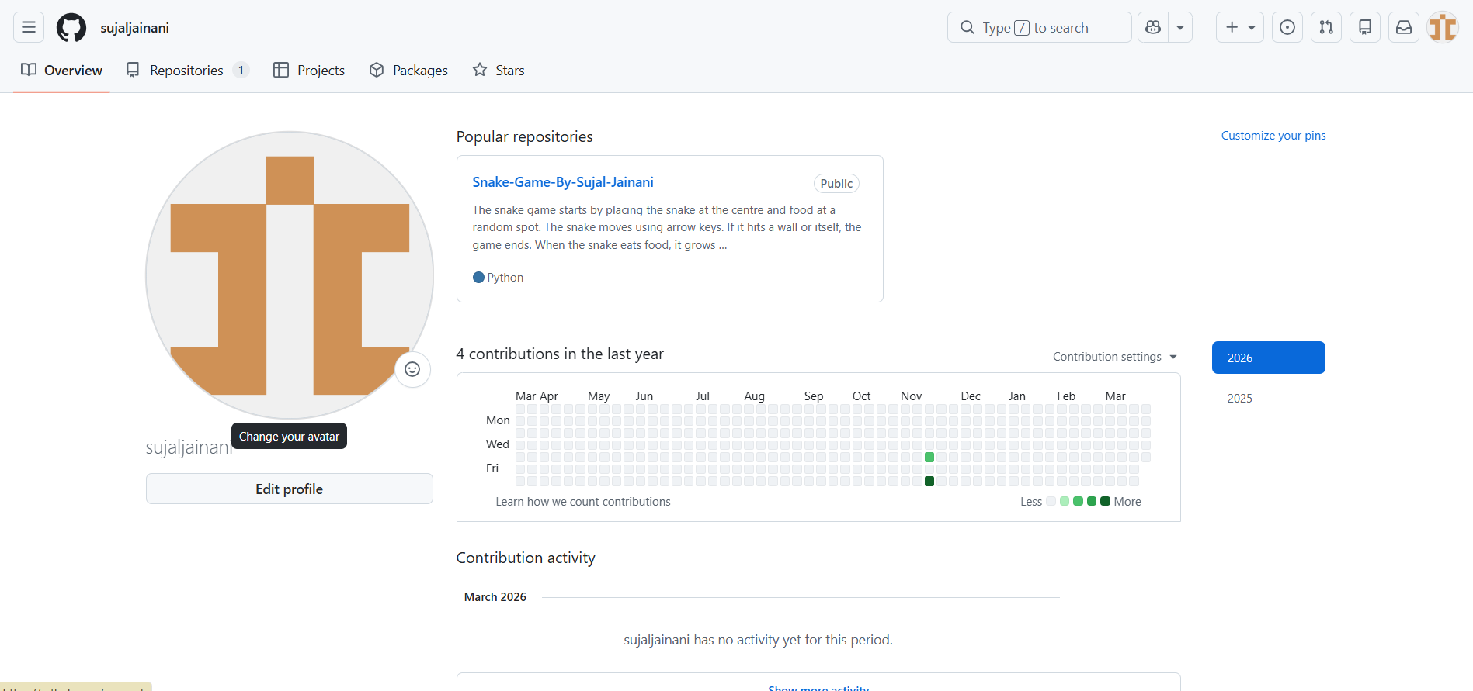

In this task, I have created and updated my digital profiles on the platforms such as GitHub, Linkedln and Kaggle. These platforms are important for building a professional online presence. GitHub is mainly used for sharing coding projects and collaborating with others, while Linkedln helps in professional networking and exploring the career opportunities. Kaggle is used for learning data science and improving analytical skills. While setting up these profiles, I ensured that my information was accurate and professional.
I added my educational details on Linkedln and created a profile README on GitHub to introduce myself. This helped me understand how to present myself in a professional manner online.
This task showed me the importance of maintaining a digital identity. In the future, I plan to regularly update these platforms by adding my projects, skills and achievements. This will help me to build a strong portfolio for internships and job opportunities.
Task 3: Explore Coding & Collaboration Platforms

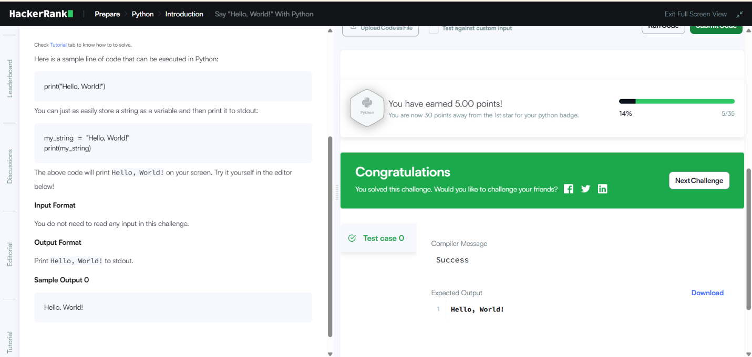

Google Form Link: https://docs.google.com/forms/d/e/1FAIpQLSdt7jjAnT1KlgvFJ5-xl2ZNOHy-I-eQ62l8D3lUS1NM49CyIw/viewform?usp=publish-editor

In this task, I explored coding and collaboration platforms. For the coding part, I used HackerRank and completed a beginner-level problem. This helped me to understand basic problem-solving and programming concepts. It was a good experience as it introduced me to the coding platforms that are useful for practice and skill development.
For the collaboration part, I created a Google Form also with five questions related to digital literacy awareness. The form included both multiple-choice and short-answer questions. I also viewed the responses in Google Sheets, which helped me understand how data can be collected and analyzed.
This task helped me to learn how online platform can be used for both learning and collaboration. Coding platforms improve logical thinking, while tools like Google Forms help us in sharing knowledge and collecting feedback. These tools will be very useful for my academic journey.
Task 4: Email Etiquette and Social Media Awareness

In digital communication, proper email etiquette is very important as it create a good impression and ensure clear communication. In this task, I learned how to write professional emails with a proper structure, including a clear subject line, polite greeting, well-organized content, and a formal closing. Writing emails in a respectful and clear manner helps in academic and professional communication.
I created a social media do’s and don’ts checklist, which highlights responsible online behavior. Social media should be used carefully, as inappropriate posts or sharing personal information can lead to problems. It is a common example of poor communication is sending emails without a subject line or proper greeting.
Such emails may be ignored or misunderstood. To avoid this kind of problem, it is important to follow proper email format and maintain a polite tone. This task helped me understand the importance of professional communication and responsible use of digital platforms.

Task 5: Cybercrime Awareness Case Study & Prevention Guide

In this task, I research and learned about cybercrime awareness and focused on UPI fraud, that is a common issue in India. I learned how attackers trick people into sending money through fake payment requests or links. Many people suffer to such scam due to lack of awareness.
While studying this topic, I was surprised to see how easily people can be targeted through simple tricks. Students and elderly people are often the main targets. This made me realize the importance of being cautious while using digital payment systems.
I also created a prevention checklist that includes steps like not sharing OTP, verifying payment requests and using trusted applications. Reporting fraud through the National Cyber Crime Portal and helpline 1930 is also important.
This task helped me become more aware and caucious of online threats. In the future, I will be more careful while using digital platforms and will also spread awareness among others.

CONCLUSION
This project provided me the valuable insights into digital literacy and it is important in today’s world. I learned how to use the various types of digital tools effectively and responsibly. Creating an infographic setting up professional profiles and understanding email etiquette helped me improve my communication and technical skills.

The cybercrime awareness task was particularly useful in understanding online threats and safety measures. Overall this project enhanced my confidence in using digital platforms and prepared me for future academic and professional challenges.

Reference

Canva.com
GitHub.com
LinkedIn.com
Google Forms
HackerRank

